1. DDL Commands – CREATE, ALTER, DROP

* Create a table name STUDENT with following structure

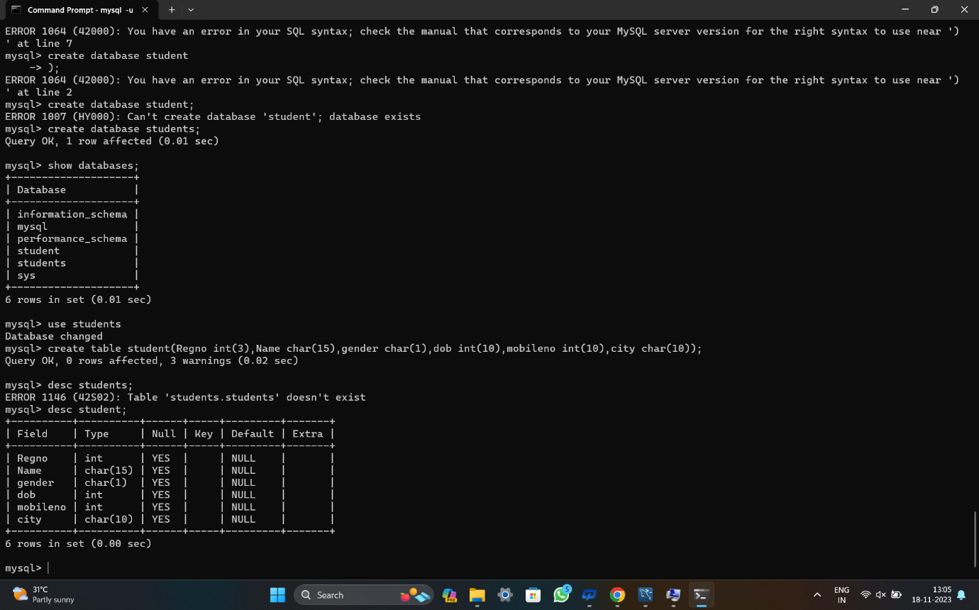

* Create a table name FACULTY with following structure.

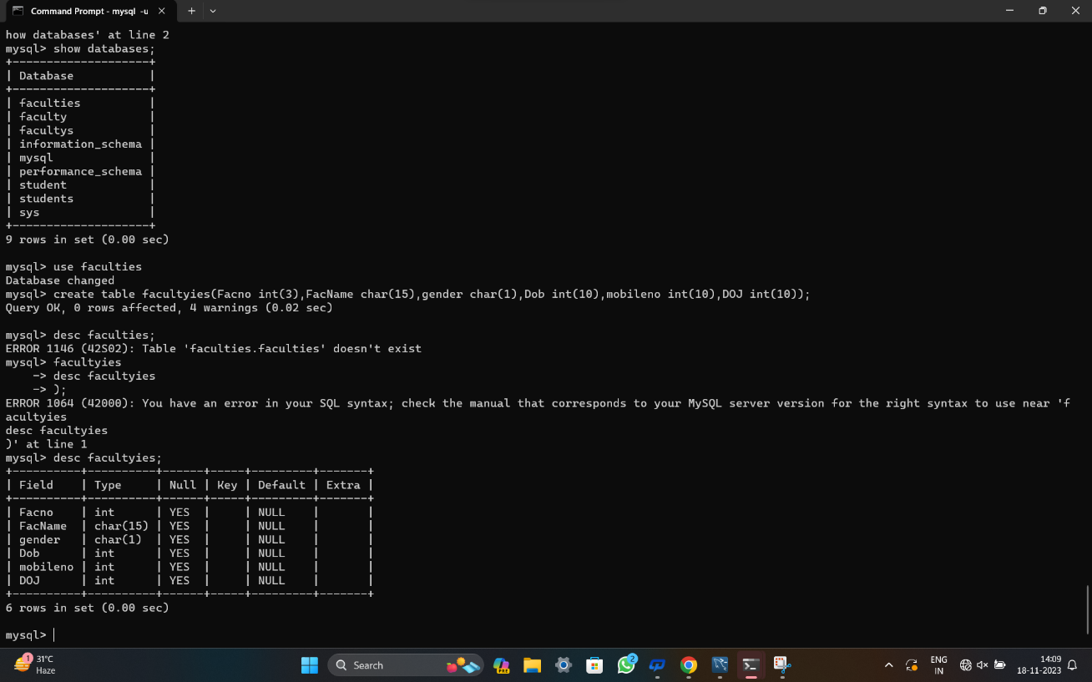

* Create a table name DEPARTMENT with following structure.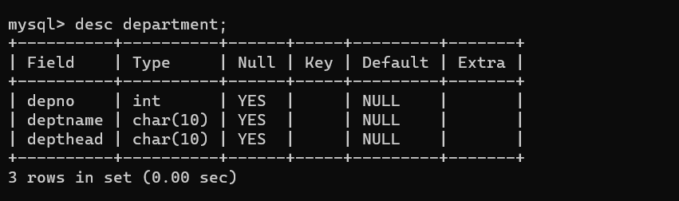
* Create a table name COURSE with following structure.

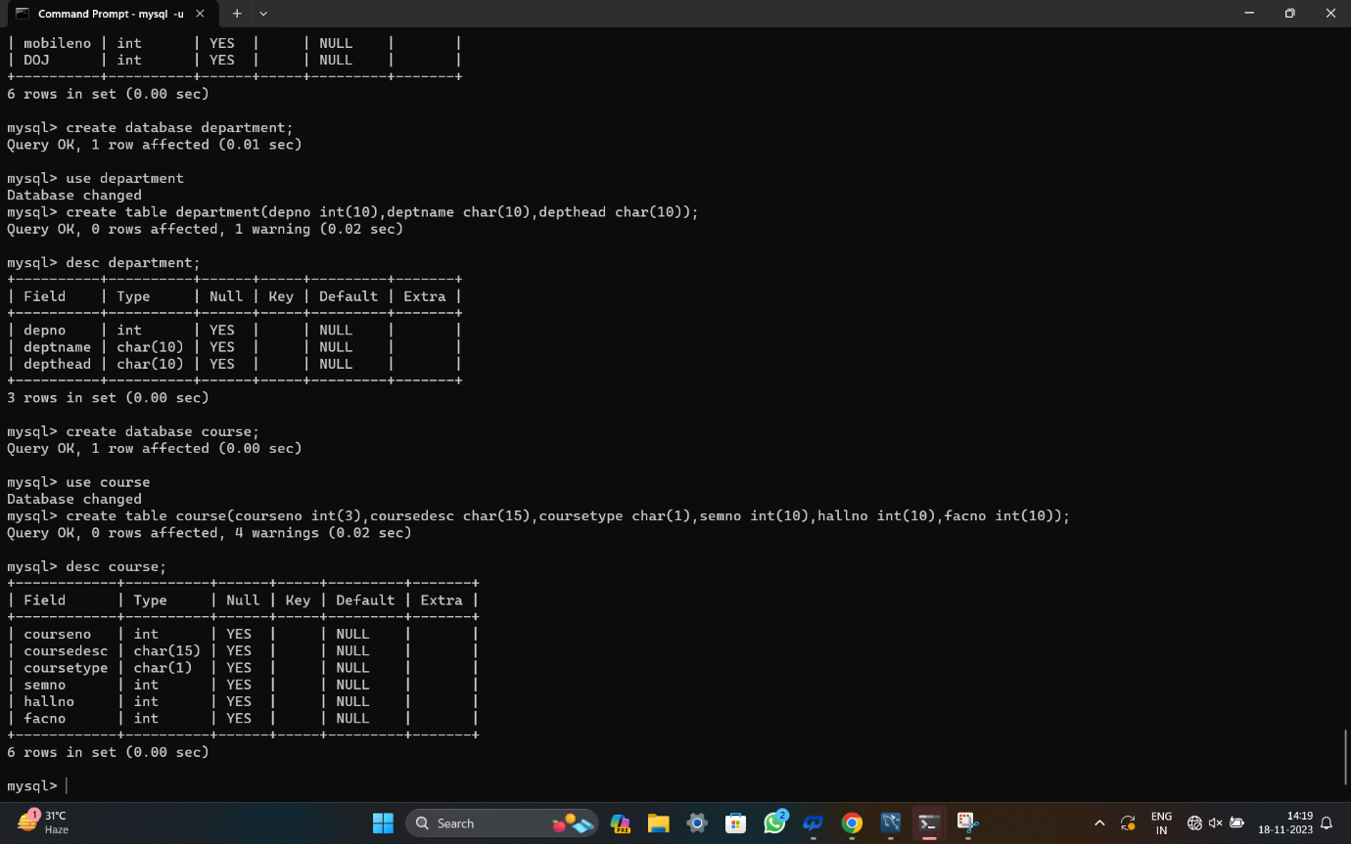

* Modify the table FACULTY by adding a column name DeptNo of datatype VARCHAR(4)

